How to watch TV in this condo

First, we have joined a movement and have “cut the cable” and no longer have an account with DirecTV which is the only provider in the Black Creek Sanctuary community. But we still enable you, our amazing guests, to be entertained with live TV and Movies using APPS such as Sling TV and Netflix. You do this utilizing our ROKU devices attached to each TV. These APPS are to be used just like the APPS on your smart phones

Each ROKU device is already connected to our TVs using one of the available HDMI slots. When you turn on the TV, using the ROKU remote or the TV remote, the ROKU is automatically activated.

The ROKU remote looks like this… the button denoted by the RED arrow turns on the TV its attached to. The buttons denoted by the BLUE arrow is the volume control for the TV
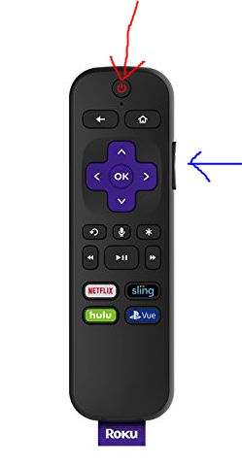

Once you turn on the TV you will see this screen……………………

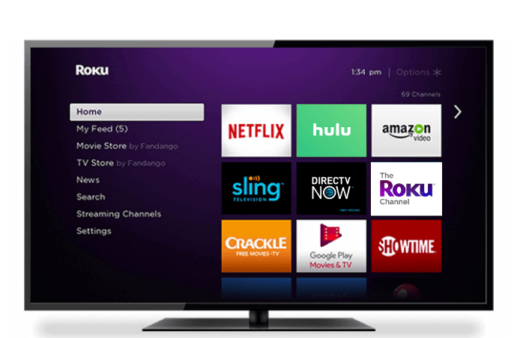

Use the ROKU remote and its 4 arrows 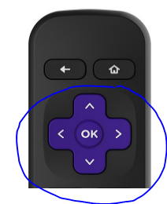
to move around the APPS pictured here and press the OK button once you find the one you want to watch….

For live TV select SLING TV of which we have a subscription to. The current channels you will have access to are:

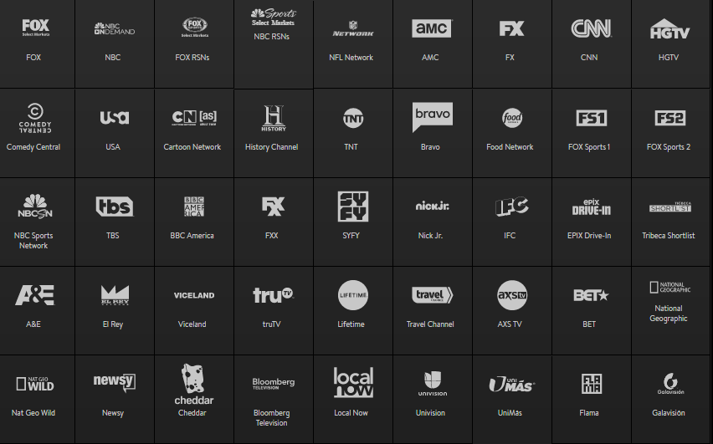

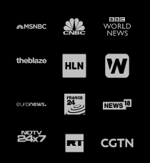

What exactly is Roku?
Roku is a digital media player that allows you to stream video, music, and entertainment content. Think of Roku as a DVD player you never have to put a disc in. Roku comes in many different forms, from set-top boxes to TV sets with the service built into them. What all Roku devices have in common, however, is the ability to give you access to a host of the biggest content providers on the planet.
With Roku, you can stream Amazon Video, Netflix, HBO Go, Hulu Plus, Spotify, MLB, and more from the comfort of your home sofa without needing to pay for a cable package. Roku is the ideal media center for viewers who don’t want to have to buy a video game console to watch digital content. It’s affordable, versatile, and easy to use.

How does Roku work?
Roku requires an internet connection. Once you connect the device to one of your TV’s HDMI ports, Roku will walk you through setting up your internet connection and creating a Roku profile. Every Roku device comes with a remote that you use to navigate through menus and select programming. When you first start using Roku, you’ll find the service comes preloaded with some of the most traditional services, including Netflix, Amazon Video, and Hulu. But there’s plenty more to discover. Roku has more than 3,000 available channels that you can connect to from the Roku channel store. To find new channels go the main menu and select “Streaming Channels.” From there you can search channels by category, from 4K content to the top free channels. Some channels, like Netflix and Hulu, require you to have a subscription, but there are free options like Crackle that offer ad-supported programming.
Roku makes cord-cutting easy. If you’re looking to replicate your cable service without a visit from a scheduled technician and a long-term contract, Roku is an ideal for live TV streaming through services that include Sling TV, Hulu with Live TV, CBS All Access, DirecTV Now, FuboTV, Philo, and PS Vue.

